**Summer Learning**

**Space-craft Dynamics**

Transport Theorem

Attitude Coordinates

Direction Cosine Matrix

Orthogonality and Determinant

Coordinate Frame Transformation and Addition of DCMs

Kinematics Differential Equation

Euler Angles

Euler angles to rotation matrix

Euler angle Addition and Subtraction

Euler angle KDEs

Addition of symmetric euler angle

PRVs and Quaternions

Principal rotation vectors

Euler’s rotation theorem

PRVs addition and subtraction

PRVs KDEs

Quaternions

Quaternion Rotation

Quaternions to DCM

Quaternion Addition and subtraction

Quaternion differential equations

Rodrigues parameters

Rodrigues’ rotation formula

Classical Rodrigues parameters (CRPs)

CRPs to DCMs

CRPs addition and subtraction

CRPs KDEs

Modified Rodrigues parameters (MRPs)

MRPs to DCMs

MRPs addition and subtraction

MRPs KDMs

Special Relativity

Space-time or Minkowski Diagram

Lorentz Transformation

**Astrophysics**

Hertzsprung-Russell Diagram

Color-Magnitude diagram

Theoretical HR diagram

Stellar Evolution

Early Stages

The Main Sequence

Energy Transport in M.S. stars

Stellar Evo after MS

Horizontal Branch

Instability Strip

Asymptotic giant branch

Red giant branch

Helium flash

Triple alpha process

End of stellar Evolution

White dwarfs (degenerate dwarfs)

Contact binaries

Cataclysmic variables

Core Collapse aka The Gravothermal Catastrophe

Red Dwarfs

Neutron stars

Pulsars

Black Holes

Stellar Black Holes

Hawking radiation

Gamma ray bursts

The Milky Way

Galactic Center

The Bulge

Spiral Arms

Galactic rotation

Reason of spiral arms

Density wave theory

Supernovae

Type Ⅰa

Core collapse supernovae (Type Ⅰb, Type Ⅰc, Type Ⅱ)

Star Clusters

Stellar Dynamics

Chandrasekhar Friction or Dynamical Friction or Gravitational Drag

Misc

Absolute and Apparent Magnitude

Cepheid Variables

Classical Cepheids (Also known as Population Ⅰ / Type Ⅰ / Delta Cepheids)

Type Ⅱ Cepheids (Also known as Population Ⅱ Cepheids)

Stellar Aberration

Eddington Limit/Luminosity

Spectral class

Luminosity Class

Color index

Machine Learning

# **Space-craft Dynamics**

## Transport Theorem

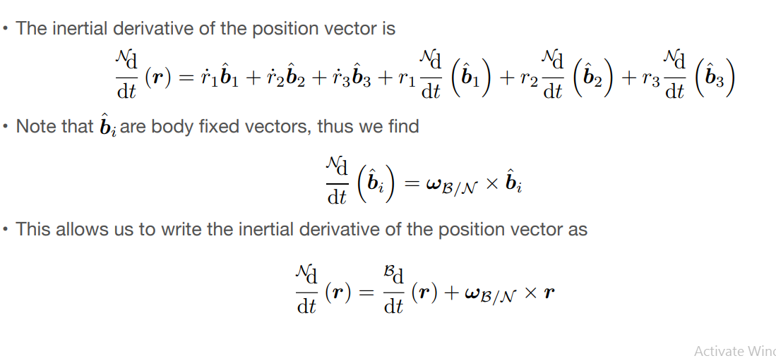

**Here N and B can be any two frames.**

## Attitude Coordinates

Attitude coordinates are a set of coordinates that describe both a rigid body and a reference frame.

* A minimum of 3 coordinates is required to describe the relative angular displacement between two reference frames.
* Any minimal set of three coordinates will contain at least one geometrical orientation where the coordinates are singular, namely at least two coordinates are undefined or not unique.
* At or near such a geometric singularity, the corresponding kinematic differential equations are also singular.
* The geometric singularities and associated numerical difficulties can be avoided altogether through regularization. Redundant sets of four or more coordinates exist that are universally valid.

## Direction Cosine Matrix

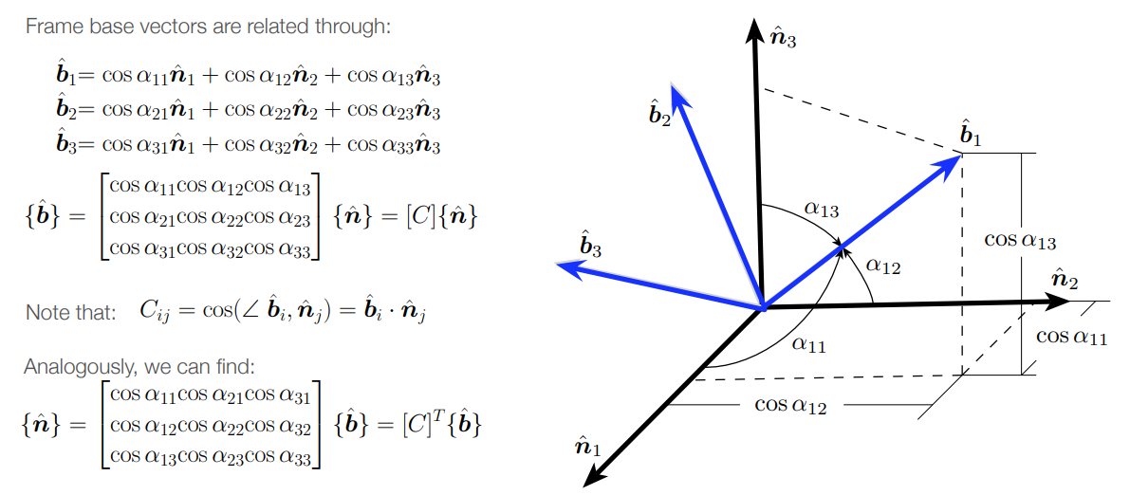

### Orthogonality and Determinant

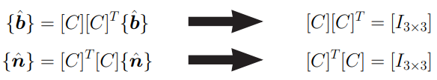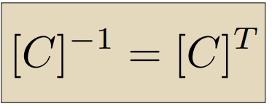

### Coordinate Frame Transformation and Addition of DCMs

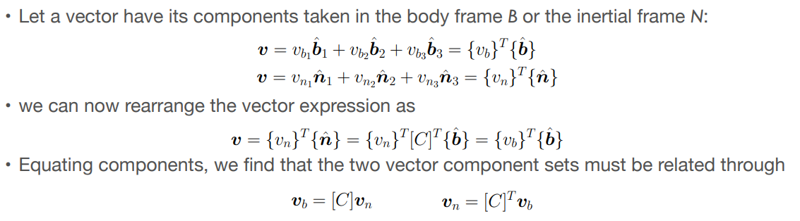

## Kinematics Differential Equation

## 

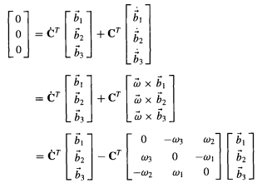

# 

# 

# 

*Here the time derivative is in Reference Frame A.*

## Euler Angles

Used to describe the orientation of a rigid body with respect to a fixed coordinate system.

There are 12 possible sequence of rotation axes

* Proper/Classic/Symmetric Euler angles (z-x-z, x-y-x, y-z-y, z-y-z, x-z-x, y-x-y)
* Tait–Bryan/Carden/Asymmetric angles (x-y-z, y-z-x, z-x-y, x-z-y, z-y-x, y-x-z)

2nd angles always defines the singularities

* For symm set - 00 or 1800
* For asymm set - +/-900

### Euler angles to rotation matrix

Let the euler angle sequence be then the final rotation matrix is

* The rotation matrix will be the same for any euler sequence, so we can use this to convert between euler sequences.

### Euler angle Addition and Subtraction

Assume we have an inertial frame N, a reference frame R, and a body frame B.

For adding the angles we have to add their rotation matrices.

Similarly for subtraction we transpose the rotation matrix the multiply.

Other steps are the same as addition.

### Euler angle KDEs

### 

# 

# 

# 

# 

# 

# 

**The KDEs are different for all euler sequences.**

### Addition of symmetric euler angle

## PRVs and Quaternions

### Principal rotation vectors

#### Euler’s rotation theorem

A rigid body or coordinate reference frame in an initial arbitrary frame can be transformed in a final arbitrary frame by a single rotation about a fixed axis in both the frames.

The fixed axis is a unit eigenvector of the rotation matrix with eigenvalue one.

Let the fixed vector be and the rotation angle be , then there are 4 possible principal rotations. where

#### PRVs addition and subtraction

We can convert the PRVs to DCMs and then add/subtract them but there are also direct formulas for addition and subtraction.

Direct Addition (Without converting into DCMs)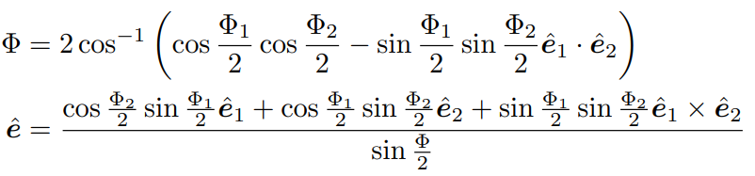

#### 

#### 

Direct Subtraction (Without converting into DCMs)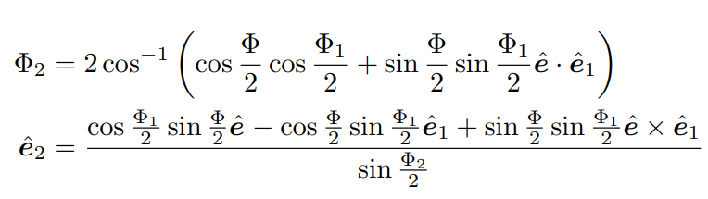

# 

### 

#### PRVs KDEs

From angular velocity to PRV rates

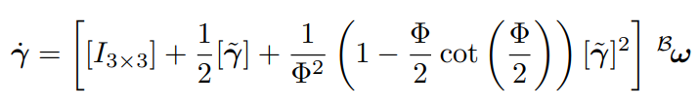

#### 

#### 

From PRV rates to angular velocity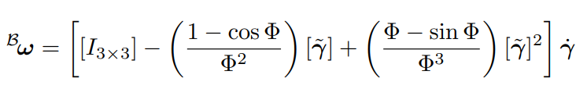

### Quaternions

A 4-D number system that extends complex numbers.

Generally represented in the form

Where a, b, c, d are real numbers and i, j, k are the fundamental quaternions units.

Quaternions are divided into two parts

1. Scaler OR Real part -
2. Vector OR Imaginary part -

The multiplicative group structure of quaternions is called the Hamilton Product.

* 1, the real quaternion, is the identity element.
* The Hamilton Product is not commutative.
* Every non zero quaternion had an inverse with respect to the hamilton product
* Norm of quaternion is

#### Quaternion Rotation

Unit quaternions, with norm = 1 and also known as versors, are mathematically convenient for representing orientation and rotation of objects in 3-D.

When used to represent rotation they are called rotation quaternions and when used to represent orientation they are called orientation/attitude quaternions.

The equation for spatial rotation of angle θ about a unit axis is the quaternion:

#### Quaternions to DCM

**This matrix can be derived from the PRV rotation matrix by using some trigonometric identities.**

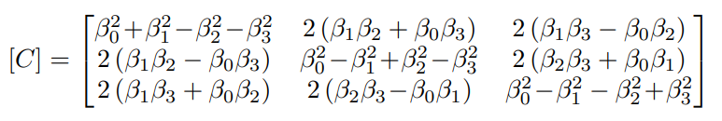

We can find the quaternion using **sheppard’s method**.

This method is more robust and we can avoid singularities using this method.

1. *We have to find the largest term.*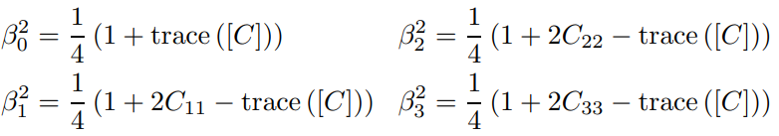
2. *Then we will use that term to calculate the rest terms.*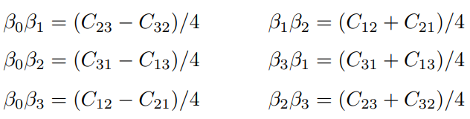

#### 

#### 

#### 

#### 

#### Quaternion Addition and subtraction

We can convert the quaternions to DCMs and then add them and then convert them back to quaternions. But we can also use these formulas.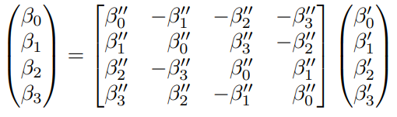

# 

By shuffling the terms in the equations we can also write the matrix like this

# 

# 

To subtract two orientations we can use the inverse, which is the same as the transpose because the matrices are orthogonal, of the previous two matrices.

#### Quaternion differential equations

We can derive the DEs using the DEs of DCMs and the relation between quaternions and DCMs.

We use different forms of the DEs for different tasks.

This is the most basic form of DEs.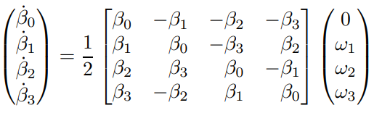

Rearranging the terms on the right hand side of the equation we get: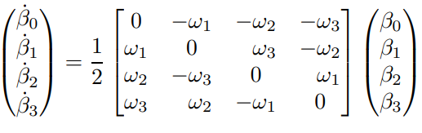

The DEs can also written in the following convenient form for numerical integration:

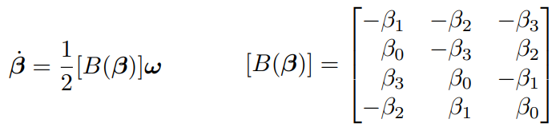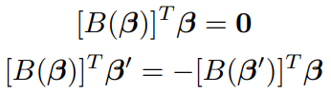

In control applications, the vector and scalar parts are sometimes treated separately.

## Rodrigues parameters

Sometimes called gibbs vectors or rodrigues vectors.

#### Rodrigues’ rotation formula

If is a vector in ℝ3 and is the unit axis of rotation about which is rotated by angle , the formula for is

### Classical Rodrigues parameters (CRPs)

The CRPs are defined as the vector part of quaternions divided by the scalar part.

And the gibbs vector is .

* CRPs have only one singularity at
* CRP for an orientation is unique

#### CRPs to DCMs

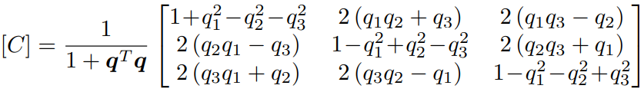

The DCM is orthogonal and

The vectorized form of the matrix C is given below.

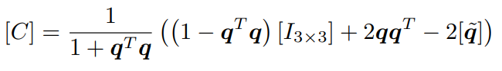

#### 

Here given by

#### 

#### 

#### CRPs addition and subtraction

A rotation q1 followed by another rotation q2 has the simple rotation composition form

#### CRPs KDEs

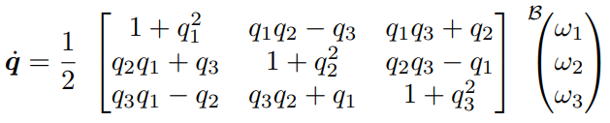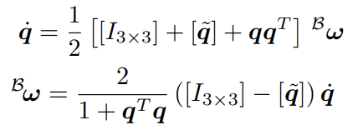

Singular at

### Modified Rodrigues parameters (MRPs)

The MRPs are defined as the ratio of vector quaternions and 1 + scalar quaternion.

* Singularity occurs at
* These parameters are not unique and the shadow MRPs are defined below

Using the alternate set of quaternions we get

Relation to CRPs and quaternions

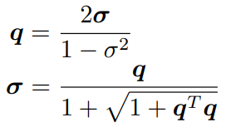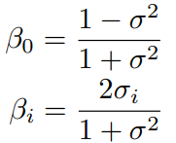

#### MRPs to DCMs

We can compute the DCM using the DCM of CRPs and the relation of MRPs and CRPs.

The DCM is orthogonal and

The vectorized form of the matrix C is given below.

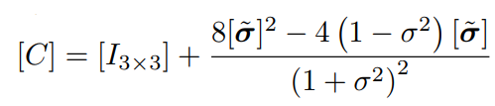

Here is given by:

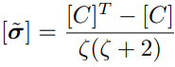

#### MRPs addition and subtraction

We can always use DCMs but we also have direct formulas.

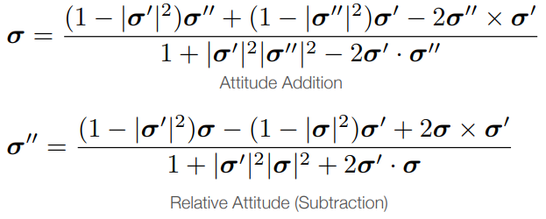

#### MRPs KDEs

Vectorized form: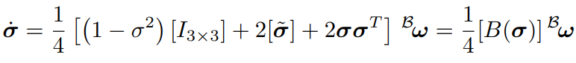

The Inverse Transformation:

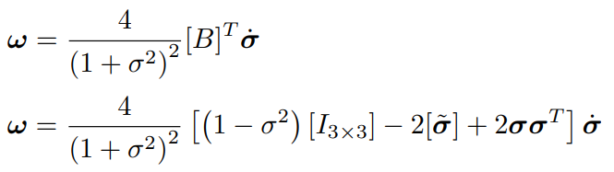

# 

## Attitude Determination

It is divided into two parts.

1. Static Attitude Determination - All measurements are taken at the same time and then using this snapshot we can determine the attitudes.
2. Dynamic / Sequential Estimation - Measurements are take over an amount of time, along with some gyro (rotation rate) measurements which then optimally blended together (Kalman filter).

### TRIAD method

# **Special Relativity**

## Space-time or Minkowski Diagram

Two dimensional graphs depicting events happening in the universe consisting of one space dimension and one time dimension.

* Time on vertical axis and distance on horizontal axis
* Measurements are chosen such that the object moving with speed of light is a 450 line.

The line traced by the object is called the world line. And each point in the diagram represents a certain point in spacetime and is called an event.

## Lorentz Transformation

A linear transformation from one coordinate frame in spacetime to another that moves at a constant velocity relative to the other.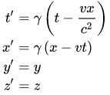

Here is the lorentz factor and

### Derivations

### Velocity addition

We can derive this by differentiating the lorentz transformations.

Parallel velocity addition



Perpendicular velocity addition

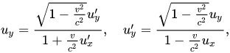

# **Astrophysics**

## Hertzsprung-Russell Diagram

A scatter plot of stars showing the relations between absolute magnitude or luminosity of the stars vs their spectral class or effective surface temperature.

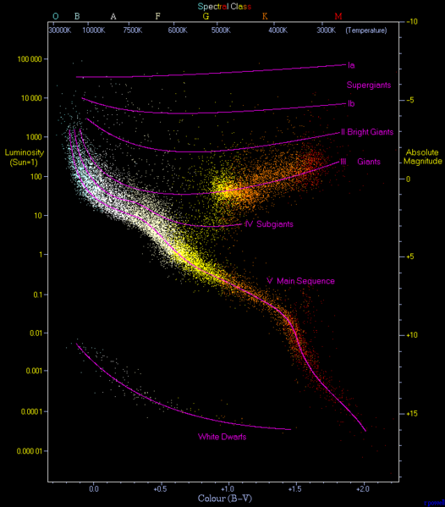

#### Color-Magnitude diagram

In modern versions spectral class is replaced by color index (most often B - V color). This type of diagram is called an observational HR diagram or a color-magnitude diagram (CMD), it is used by observers.

When the stars are at identical distances ( like in a star cluster) a CMD is used to describe the stars by plotting against apparent magnitude.

#### Theoretical HR diagram

HR diagram with luminosity vs effective surface temperature, this could be called temperature-luminosity diagram, but this term is hardly ever used.

In this HR diagram the temperatures are plotted from high to low, which helps in comparing this form of the HR diagram with the observational form.

Although these two forms are similar but astronomers make a sharp distinction between the two. The transformation from one to the other is not trivial. For transformation we require a color-temperature relation and constructing that is very difficult.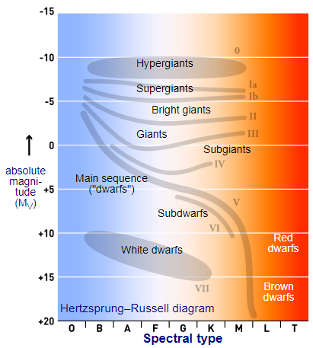

### 

### 

## Stellar Evolution

### Early Stages

#### The Main Sequence

* Stars burns H into He in their cores
* Main sequence lifetime is strongly mass-dependent
* Luminosity is proportional to M3.5 and Tms to M-2.5
* Lower M.S. stars, with mass < 1.5M☉, fuse H using proton-proton chain
* Upper M.S. stars, with mass > 1.5M☉, fuse H using CNO cycle

#### Energy Transport in M.S. stars

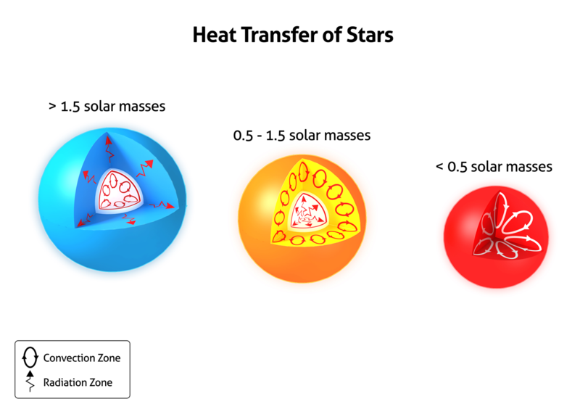

**All the numbers mentioned here are not exact.**

### 

### Stellar Evo after MS

#### Horizontal Branch

A stage of stellar evolution powered by helium fusion in the core (via triple-alpha process) and hydrogen fusion in the shell (via the CNO cycle), that immediately follows the red giant branch in stars with similar mass as the sun.

#### Instability Strip

The region of the HR diagram occupied by several classes of pulsating variable stars like Delta Scuti variables etc.

#### Asymptotic giant branch

#### Red giant branch

#### Helium flash

A very brief thermal runaway nuclear fusion of He, accumulated after H fusion, into C via the triple alpha process.

* Happens in low mass stars (around 0.8Msun - 2Msun) during the red giant phase.
* A rare helium fusion occurs on the surface of accreting white dwarfs.
* It can generate more luminosity than an entire galaxy for a few minutes.
* It doesn’t destroy the star because the envelope absorbs the energy.

#### Triple alpha process

A set of nuclear fusion reactions that converts 3 4He nuclei into a carbon nuclei.

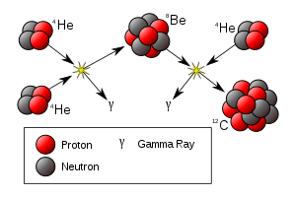

For this process to occur carbon nucleus has to have exact same energy levels as of He and Be.

### End of stellar Evolution

For stars with initial mass -

* < ~8Msun will turn into a white dwarf and planetary nebula.
* > ~8Msun will turn into a black hole and supernovae.

#### White dwarfs (degenerate dwarfs)

A stellar remnant of a star with mass < ~8Msun, it is one of the end stages of star life.

* Masses are up to 1.4Msun = the chandrasekhar limit
* Radius ~ M-1/3

#### Contact binaries

A binary star system whose stars are so close and massive that they can touch each other. They can interact/exchange masses and that can significantly affect their evolution.

* Roche lobe is the surface where the gravitational potential of both stars are equal.
* Inner Lagrangian point is the point where the roche lobes of the star connect.
* Mass transfer occurs when a star overflows its roche lobe, the mass flow occurs through the inner lagrangian point.
* An accretion disk can form around the object due to rotation.

Accretion power

As the material falls towards the star it acquires a kinetic energy that is radiated in x-rays, UV and visible light.

ΔKE = ΔPE ≈

Luminosity = dE/dt =

#### Cataclysmic variables

Stars which irregularly increase in brightness by a large factor due to variation in mass accretion rate that can change the luminosity drastically.

* These stars are part of contact binaries with generally white dwarfs.
* The material can fall on the surface of the WD or NS to produce a layer in which thermonuclear reactions can ignite, causing an explosion and increase in luminosity, that is called NOVA.

#### Core Collapse aka The Gravothermal Catastrophe

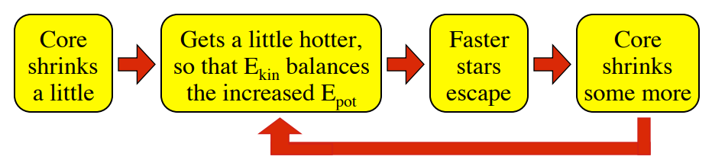

* If the collapse continues then theoretically it will turn into a black hole.
* The only way to arrest the collapse is to provide a source of energy in the center to replace the escaped heat.
* In case of protostars this energy is provided by thermonuclear reactions, and for globular clusters by Hard Binaries.
* Binary stars can either take or give energy to a passing star.
* Hard binaries a=give more energy than they take, thus they serve as energy source and arrest core collapse and stabilize the cluster.

#### Red Dwarfs

* Mass < .4Msun
* All convection zone
* H & He mixed throughout the star
* Burns H slowly and will never build He core and ignite He
* Will fade as a black dwarf

#### Neutron stars

Neutron star is the collapsed core of a giant star. They result from supernova explosions that compress the core past white dwarf.

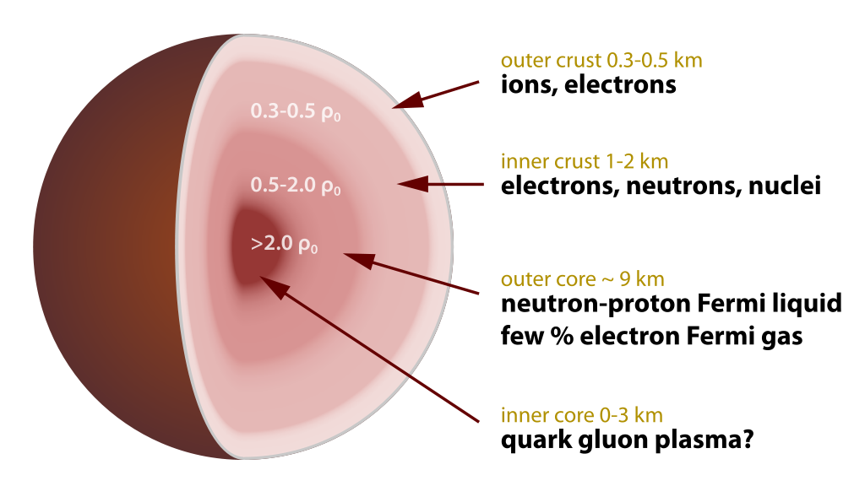

#### Pulsars

Pulsars are highly magnetic and rotating neutron stars that emit EM beams out of their magnetic poles. The conservation of angular momentum during core collapse gives it the spin. The magnetic poles and rotation axis need not be aligned, thus the radiation sweeps around as a lighthouse beam.

Because of their huge moment of inertia they are extremely stable and as steady as (or better than) atomic clocks.

They slow down gradually due to the energy they radiate.

Sudden decrease in periods can be caused by starquakes by lowering the moment of inertia.

Binary Pulsars - A pulsar with a binary companion (often WD or NS, maybe another pulsar). They rotate around very close and very fast so some of the KE is radiated as gravitational waves that proves the general theory of relativity.

X-ray bursters and millisecond pulsars - Neutron stars can be accreting binaries such system become x-ray bursters and accreting disk material can also increase the angular momentum of a pulsar and it can become a millisecond pulsar.

### Black Holes

#### Stellar Black Holes

A region of spacetime where the gravity is so strong that nothing, not even em radiation (light), can escape it i.e. their escape velocity is greater than c (speed of light).

The boundary of the black hole, where escape velocity is equal to c, is called the event horizon. The radius of the event horizon is called Schwarzschild radius. For a non-rotating black hole Schwarzschild radius is ***GM/c2*** and things are more complicated for a rotating black hole.

At the center of a black hole lie a gravitational singularity where the spacetime curvature becomes infinite. It is a point for non-rotating BHs and a ring (in the plane of rotation) for rotating BHs. It has zero volume in both cases.

The singularity contains all mass of the black hole and has infinite density and gravity.

#### Hawking radiation

#### Gamma ray bursts

## Galaxies

### The Milky Way

* Barred spiral shaped galaxy ( spiral galaxy with a central bar shaped structure with stars)
* The solar system is at ~27000 light yrs from the galactic center.

#### Galactic Center

The galactic center of the milky way is marked by an intense radio source called Sagittarius A* (Sagittarius A star), A supermassive black hole with mass ~4.31 million solar masses. The rate of accretion, around 10-5 Msun per year, suggested that it is an inactive galactic nucleus.

#### The Bulge

Bulge is a tightly packed group of stars, mostly in the center of a galaxy.

Classical bulges

* Properties similar to elliptical galaxies
* Generally contain old P Ⅱ stars, hence have a reddish hue
* Due to stars random orbit compared to galactic plane, the bulge have a spherical shape
* Have no star formation due lack of gas and dust.

Disk-like bulge

* Central regions of spiral galaxies, often referred to as pseudobulge or disky bulge.
* Stars orbit in the galactic plane

In the milky way the stars in the innermost ~104 light yrs forms the bulge (disk-like) and the bars.

#### Spiral Arms

Our galaxy has four spiral arms that all start near the center.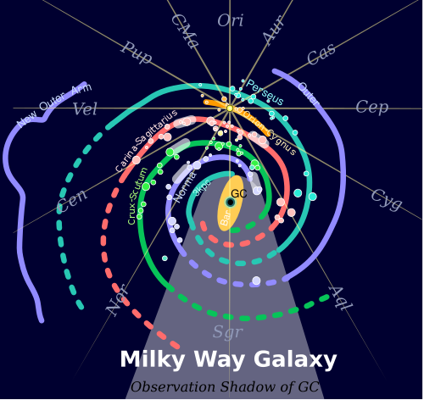

### 

### 

### 

### 

### 

### 

### 

1. Near 3 kpc Arm and Perseus Arm
2. Norma and Outer Arm
3. Scutum-Centaurus Arm
4. Carina-Sagittarius Arm

There are at least 2 smaller arms or spurs including

1. Orion-Cygnus Arm (Contains solar system)

#### Galactic rotation

The stars and dusts in the milky way rotates about its center differentially i.e. different locations have different angular velocities.

Rotation curve - Plot of orbital velocity of stars and gases versus radial distance from center of galaxy.

#### Reason of spiral arms

The winding dilemma - The differential rotation can cause the spirals to bound more tightly but that is not the case because that’s not how spiral arms are formed.

#### 

#### 

#### 

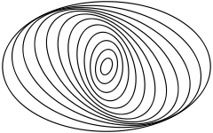

#### Density wave theory

The orbits in spiral galaxies are not circular; they are a bit elliptical and they are twisted w.r.t. each other, thus there are some regions with higher star density than others and more stars means higher gravity so other objects will get attracted toward these regions forming what we see now - the spiral arms.

### Galaxy morphological classification

#### Hubble sequence or The Hubble tuning fork diagram

Hubble’s classification divides galaxies into 3 broad classes - based on visual appearance.

1. Ellipticals - E
2. Lenticulars - S0
3. Spirals - S & SB

A 4th class contains galaxies with irregular appearance.

### 

### Elliptical galaxies

* Smooth, featureless light distribution mostly found in clusters (Dense environment)
* No spiral arms or dust lanes
* Little or no star formation
* Contains hot x-ray gas
* Old, metal-rich stellar population
* Classified by apparent ellipticity and denoted by E followed by an integer n

By convention n is 10 times the ellipticity (e = 1 - a/b), rounded to the nearest integer.

### Spiral galaxies

Consists of a flattened disk, star forming spirals (usually two), and a central concentration of stars known as bulge.

Roughly half spirals galaxies have a central bar-like structure, with the bar extending from the bulge and the arms beginning at the end. In the tuning fork diagram the regular spirals (Upper branch) are denoted by S and the barred spirals (Lower branch) are denoted by SB.

Both types are further divided into subtypes indicated by adding a lower-case letter at the end.

Subclasses from a to d - bulge become less important and more fainter and the disk becomes more important and arms become more open.

### Lenticular galaxies (S0)

Transition galaxies between elliptical and spirals galaxies are called lenticular, denoted by S0.

Consists of central bulge and appears similar to ellipticals, surrounded by disk like structures and have no spiral structures.

### Irregular galaxies

Galaxies that don’t fit in hubble sequence, because they have no regular structures, are called irregular galaxies.

Hubble divided these in two classes.

1. Irr Ⅰ - Have an asymmetric profile, lacks a central bulge, contains many clusters of young stars.
2. Irr Ⅱ - Have a smoother asymmetric profile and not clearly resolved into clusters

### Supernovae

A very powerful and bright stellar explosion that occurs during the last stages of a star.

The original object called the progenitor either collapses into a black hole or neutron star, or it is completely destroyed.

* Most energy is released in neutrinos ( ~99%, 1% in KE, 0.1% in visible light)
* After the explosion the gas expands at v > 0.01c.
* The peak luminosity is comparable to an entire galaxy before fading in several weeks or months.

Generally 1 supernova occurs per galaxy per century

The gaseous shell ejected into the interstellar medium (at v > ~.01c) is illuminated by the newly created stellar remnant (Neutron star OR Black hole) and forms what is called a supernova remnant.

The supernovae are divided into types Ⅰ and Ⅱ and many subtypes.

Type Ⅰ

* Have no lines of H in the spectrum
* Occurs in all type of galaxies
* Divided into Ⅰa, Ⅰb, Ⅰc based on their spectral properties.

Type Ⅱ

* Contains lines of H in the spectrum
* Only in star forming galaxies
* There are two mechanisms - Core collapse and annihilation of e+ and e- pairs.

#### Type Ⅰa

Occurs when a white dwarf accretes enough mass to cross the Chandrasekhar limit and degeneracy pressure can’t support the star against gravity and the star collapse.

Alternate mechanism is a spiraling than merging white dwarfs.

#### Core collapse supernovae (Type Ⅰb, Type Ⅰc, Type Ⅱ)

When Fe is in the core, further fusion is endothermic and wouldn't occur in equilibrium conditions.

As the iron core develops other reactions still proceed at larger radii and eventually Fe core becomes too massive to be supported by electron degeneracy pressure and the core collapses.

* Photo disintegration - Fe + high energy 𝛾 rays → lighter elements
* Inverse 𝛽 decay - e- + p → n + ve
* These processes accelerate the core collapse and drive the composition toward neutron rich matter.
* Core collapse produces shockwaves that actually explode the star.
* The explosion is powered by the release of binding energy of the star, as a substantial fraction of the star's mass (>2Msun) collapses into a NS or BH.
* Most of the energy is carried out by neutrinos generated by inverse 𝛽 decay.

### Star Clusters

Very large group of stars, they are divided in two categories.

1. Open Clusters - 102 to 103 stars, Age - 107 to 109 yrs.
2. Globular Clusters - 104 to 107 stars, Age - 10 to 13 Gyr (Billion yrs).

* Clusters have stars with broad mass range and at nearly the same distance so it is easy to measure relative luminosity.
* Stars in the cluster have the same age ⇒ same chemical composition.
* Clusters provides snapshot of what stars of different masses look like at the same age and chemical composition.
* Clusters have different HR diagrams.
* All share the main sequence, but have different lengths of main sequence extending to higher temperature and luminosity and then they bend over toward the red giant branch.

### Stellar Dynamics

Studying collective motion of stars subject to their mutual gravity.

#### Chandrasekhar Friction or Dynamical Friction or Gravitational Drag

Loss of momentum and KE of moving bodies due to gravitational interactions with surrounding matter in space.

INTUITION - A massive object is moving through a cloud of lighter objects. Due to the gravitational interaction between them the massive objects lose its momentum and KE to the lighter objects.

This physical mechanism is also called the slingshot effect or gravity assist.

## Misc

### Absolute and Apparent Magnitude

Apparent magnitude is the measure of brightness of an astronomical object as seen from earth. The magnitude scale is in reverse log. 5 mag. higher means 100 times dimmer.

Absolute magnitude is the measure of luminosity of a celestial object, also on inverse log scale. Absolute and apparent mag are equal if the object is seen from a distance of exactly 10 parsecs without any absorption of light by cosmic dust.

### Cepheid Variables

A type of stars that pulsates rapidly, varying both in size and temperature and changing brightness with a well defined period and amplitude.

* A cepheid variable’s luminosity and pulsation period are strongly related by period-luminosity relation, and this relation makes them a good benchmark for scaling galactic distances.
* Origin from Delta Cephei, the first identified of this type, in the constellation Cepheus.

#### Classical Cepheids (Also known as Population Ⅰ / Type Ⅰ / Delta Cepheids)

* Pulsations with very regular periods, order of days to months.
* 4 to 20 times solar mass and upto 105 times luminous.
* Yellow bright giants and SGs of spectral class F6 to K2.
* Their radii change by millions of kms.

#### Type Ⅱ Cepheids (Also known as Population Ⅱ Cepheids)

* Period of 1 to 50 days typically.
* Metal poor, old (10 Gyr), low mass stars (half the solar mass).
* Divided into 3 subclasses based on periods.
  + BL Herculis - less than 8 days, low luminosity and mass
  + W Virginis - 10 to 20 days
  + RV Tauri - greater than 20 days, alternating deep and shallow minima

### Stellar Aberration

A phenomenon which produces apparent motion of astronomical objects about their true positions, depending on the velocity of the observer.

### 

### Eddington Limit/Luminosity

The maximum luminosity a body, like a star, can achieve during hydrostatic equilibrium. When a star exceeds this limit it will initiate a very intense radiation-driven stellar wind from its outer layers.

Here M is mass of star, c is speed of light, mp is mass of proton, G is gravitational constant and is Thomson scattering cross-section.

### Spectral class

The spectral class of a star is a short code primarily summarizing the ionization state, giving an objective measure of the photosphere's temperature.

For most stars we use the Morgan-Keenan (MK) system using the letters O (Hottest), B, A, F, G, K, and M (Coolest). Each category is subdivided using digits from 0 (Hottest) to 9 (Coolest).

The sequence has been expanded for other stars and star-like objects, such as class D for white dwarfs and classes S and C for carbon stars.

#### Luminosity Class

Based on the width of certain absorption lines in the star's spectrum, which vary with the density of the atmosphere distinguishing giant and dwarf stars.

|  |  |  |  |
| --- | --- | --- | --- |
| Class | Description | Class | Description |
| 0 or Ia+ | hypergiants or extremely luminous supergiants | III | normal giants |
| Ia | luminous supergiants | IV | subgiants |
| Iab | intermediate-size luminous supergiants | V | main-sequence stars (dwarfs) |
| Ib | less luminous supergiants | sd or VI | subdwarfs |
| II | bright giants | D or VII | white dwarfs |

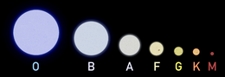

### 

### 

### 

### Color index

* Numerical expression to determine the color of an object.
* Smaller Color Index means more blue or hotter objects.
* Measured on Log scale, brighter objects have smaller magnitude.
* A hot star will emit more blue light so it will look brighter in blue filter(B) than in visible light filter(V). Since brighter means smaller magnitude B - V < 0

# Machine Learning